**Basic microcontroller (msp430) programming using C language**

**Lab02**

**Spring 2025**

Submitted by: **Mohsin Sajjad**

Registration No: **22pwsce2149**

Class Section: **A**

“On my honor, as student of University of Engineering and Technology, I have neither given nor received unauthorized assistance on this academic work.”



Student Signature: ______________

Submitted to:

**Engr. Faheem Jan**

Month Day, Year (02 03, 2025)

Department of Computer Systems Engineering

University of Engineering and Technology, Peshawar

# LAB No 2

**Basic microcontroller (msp430) programming using C language**

**TASKS:**

**TASK1:**

TASK 1 Write C program for Msp430 which toggle P1.0 or any other Pin of Msp430 MCU.

**CODE:**  
#include <msp430.h>

/*

* main.c

*/

int main(void) {

WDTCTL = WDTPW | WDTHOLD; // Stop watchdog timer

PM5CTL0 &= ~LOCKLPM5; // Disable high-impedance mode to enable GPIOs

P1DIR |= 0x01; //set P1.0 to output direction

for(;;){

volatile unsigned int i;

P1OUT ^= 0x01; //toggle P1.0 using exclusive OR

i=10000;

do i--; //do while loop for creating delay

while(i!=0);

}

}

**OUTPUT:  
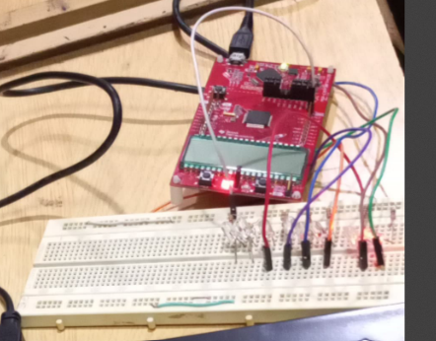**

**Conclusion:**

1. The code toggles P1.0 instead of P1.1 due to an incorrect bit mask.
2. It disables the watchdog timer and enables GPIOs.
3. Fix: Change P1OUT ^= 0x01; to P1OUT ^= 0x02; to toggle P1.1 correctly.

**TASK2: Write C program which toggle the LEDS attached with P1.0 and P1.7 at the same time with different delays.**

**CODE:**#include <msp430.h>

int main(void) {

WDTCTL = WDTPW | WDTHOLD; // Stop watchdog timer

PM5CTL0 &= ~LOCKLPM5; // Disable high-impedance mode to enable GPIOs

P1DIR |= 0x81; // Set P1.0 and P1.7 as output

for(;;) {

volatile unsigned int i, j;

P1OUT ^= 0x01; // Toggle P1.0

i = 10000;

do i--; // Delay after toggling P1.0

while(i != 0);

P1OUT ^= 0x80; // Toggle P1.7

j = 30000;

do j--; // Delay after toggling P1.7

while(j != 0);

}

}

**OUTPUT:**

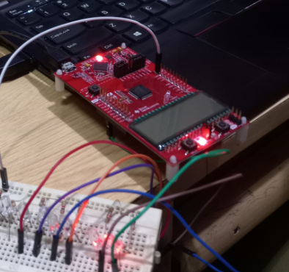

**Conclusion:**

• The code toggles P1.0 and P1.7 on an MSP430 microcontroller.

• It disables the watchdog timer and enables GPIOs.

• Separate delay loops are used for toggling each pin with different delay durations.

**TASK3: Write C program which toggle all the LEDs attached with P1 or any other PORT**

**CODE:**#include <msp430.h>

/*

* main.c

*/

int main(void) {

WDTCTL = WDTPW | WDTHOLD; // Stop watchdog timer

PM5CTL0 &= ~LOCKLPM5; // Disable high-impedance mode to enable GPIOs

P1DIR |= 0xFF; //set P1 to output direction

for(;;){

volatile unsigned int i;

P1OUT ^= 0xFF; //toggle P1 using exclusive OR

i=10000;

do i--; //do while loop for creating delay

while(i!=0);

}

}

**OUTPUT:**

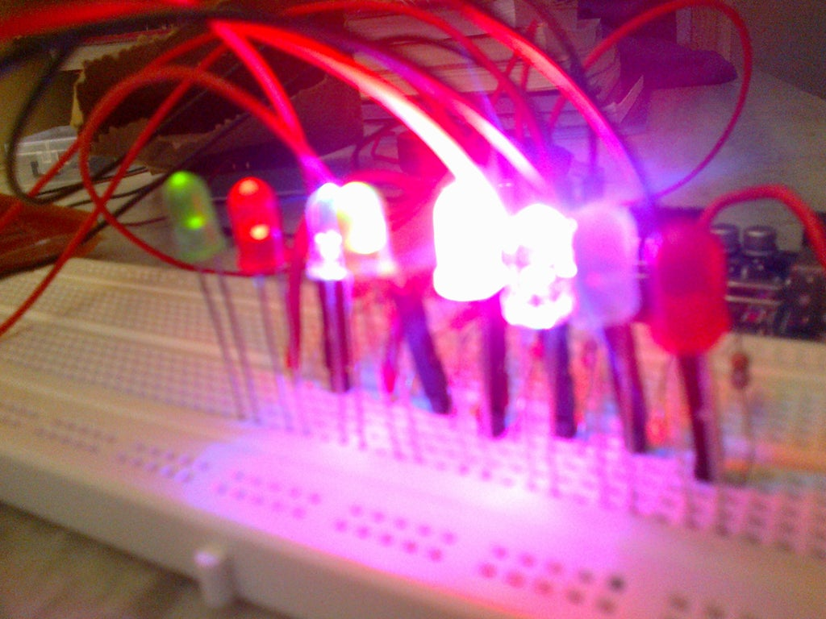

**Conclusion:**

1. The code toggles all pins of Port 1 on an MSP430 microcontroller.
2. It disables the watchdog timer and enables GPIOs.
3. A delay loop controls the blink rate of all output pins.

**TASK4: Display the pattern using C language 00000001 00000010 00000100 …. 10000000 00000001 00000010 Continuously**

**CODE:  
#include <msp430.h>**

/*

* main.c

*/

int main(void) {

WDTCTL = WDTPW | WDTHOLD; // Stop watchdog timer

PM5CTL0 &= ~LOCKLPM5; // Disable high-impedance mode to enable GPIOs

P1DIR |= 0xFF; // Set all P1 pins as output

unsigned char pattern = 0x01; // Start from P1.0

while(1) {

P1OUT = pattern; // Output the pattern

__delay_cycles(100000); // Delay for visibility

pattern <<= 1; // Shift left

if(pattern == 0x00) { // If pattern goes beyond P1.7, reset

pattern = 0x01;

}

}

}  
**OUTPUT:**  
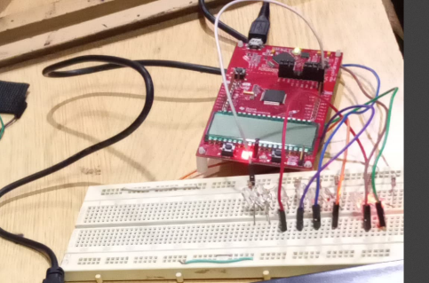

**Conclusion:**

1. The code shifts an LED pattern across all P1 pins on an MSP430.
2. It disables the watchdog timer and enables GPIOs.
3. A delay loop ensures visibility, and the pattern resets after reaching P1.7.